TABLE OF CONTENTS.

Getting Started……………………………………………………………………………..........2

Controls/Setup………………………………………………………………………………………3

Main Menu…………………………………………………………………………………………….4

Galaxy Map……………………………………………………………………………………………5

Fuel System…………………………………………………………………………………………..6

Credits…………………………………………………………………………………………………..7

GETTING STARTED

The objective of the game is to explore the solar system for Intel, but what

was a simple mission turned into something different. Something else is

out there. The player travels to planets and objects of the solar system and

learns more about them.

CONTROLS/SETUP

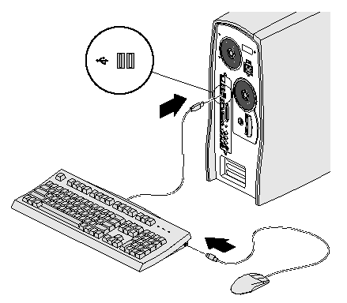

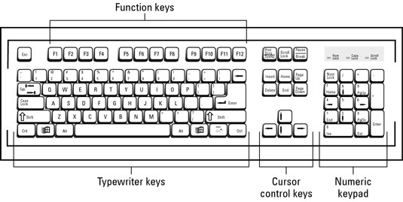

MAIN MENU

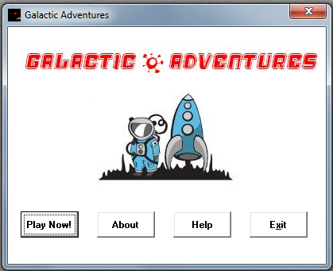

GALAXY MAP

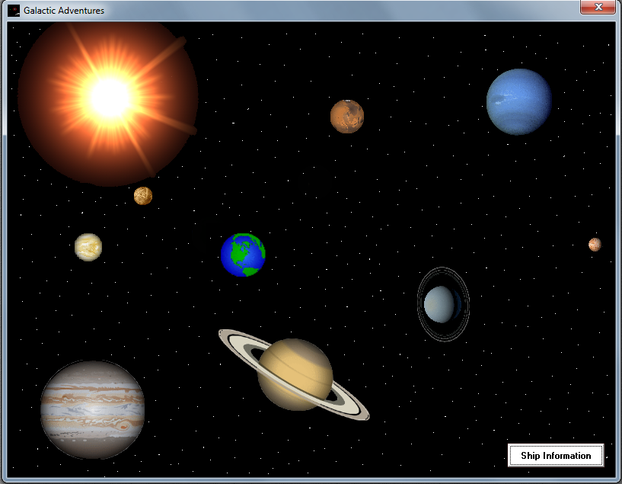

FUEL SYSTEM

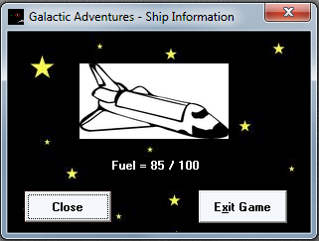

When the player travels from planet to planet the player

uses 7 gallons of fuel.

FUEL SYSTEM

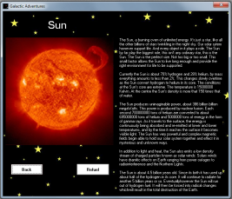After landing of the planet the player can then

refuel. The player is presented with

information on a planet and will be quizzed

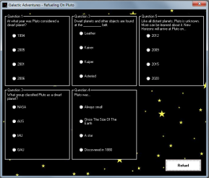on the information. For every question the

player

gets right 1 gallon of

fuel is rewarded. For every

question answered wrong the player

losses one gallon of fuel. The player

is to explore the galaxy as much as

possible to gather Intel and find the secrets of our solar system.